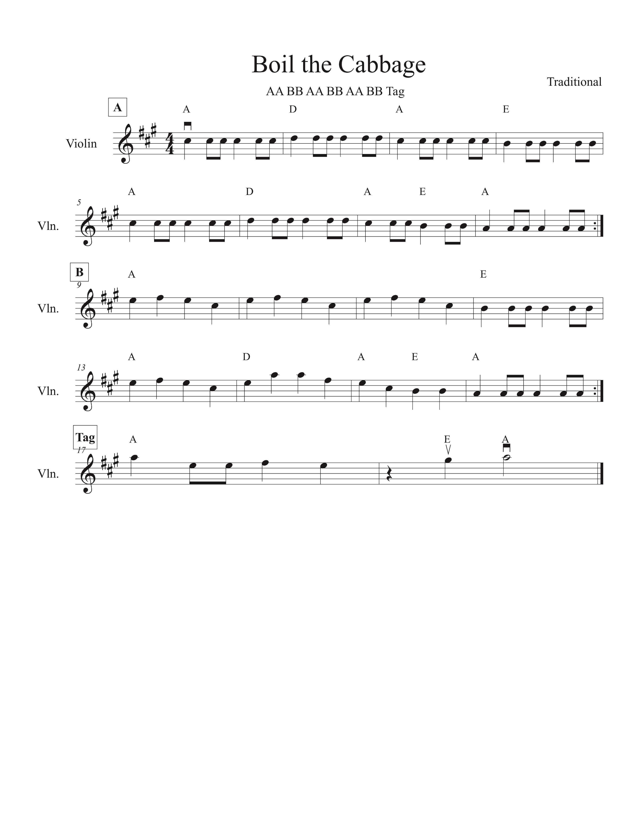

**Cabbages and Twinkles,**

**a Western Swing Fiddle and Suzuki Collaboration**

*A presentation at the American String Teachers Association Conference, March 2019*

Meredith Harris, Elisabeth Hope, Sherry McKenzie, and Danette Schuh

***fiddlesaregood.com***

**Learn the tune!**

⍈ Teaching an orchestra class? Play the tune in D Major.

⍈ Try alternating playing and singing the tune!

Bile 'em cab-bage down, down.

Bake 'em bisc-uits brown, brown

On-ly tune that I did learn was

Bile ‘em cab-bage down, down.

**Sing the tune!**

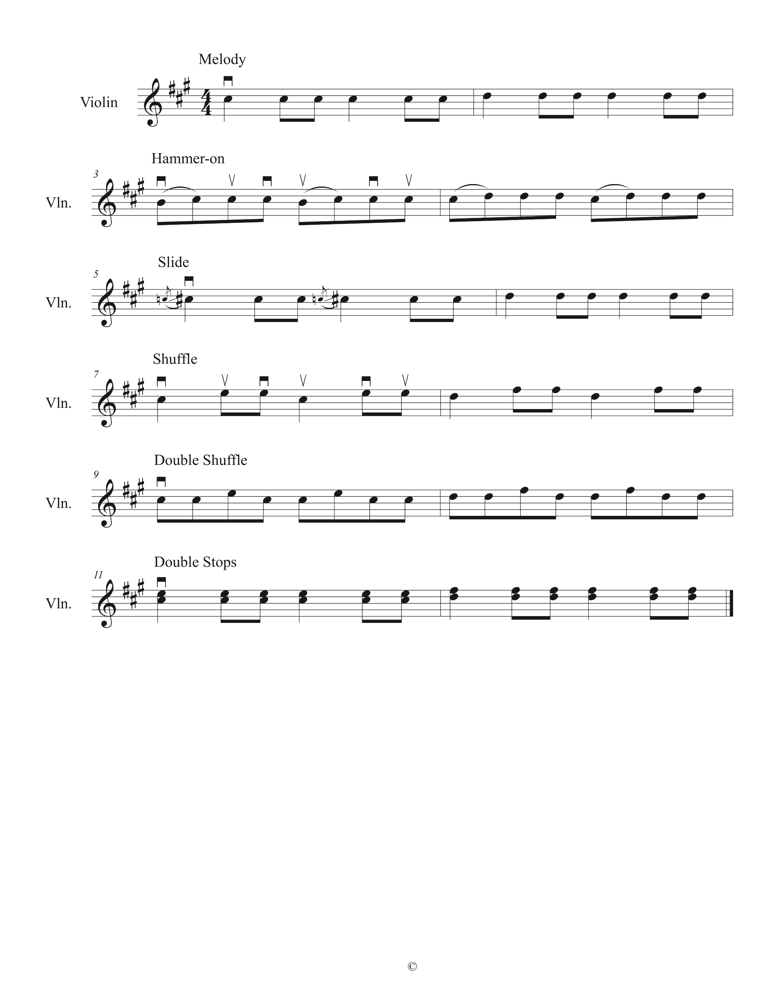

**Cabbages and Twinkles,**

**a Western Swing Fiddle and Suzuki Collaboration**

*A presentation at the American String Teachers Association Conference, March 2019*

Meredith Harris, Elisabeth Hope, Sherry McKenzie, and Danette Schuh

[***fiddlesaregood.com***](http://fiddlesaregood.com)

**Take the next step and personalize the tune!**